Turning breech upside down: upright breech birth
Shawn Walker

Introduction
Prior to the early 17th century in France, accoucheurs attended birthing women most commonly in the squatting position or on the birth stool (Speert 1957, Dunn 1991, Dunn 2004). Doctors, such as Francois Mauriceau, popularised the practice of women birthing on a bed and it was from this that differences in the physiology of birth were observed, especially with breech babies, who required additional assistance to be born. Women birthing in the supine position provided Mauriceau with the opportunity to practise his breech extraction skills.

Those were the days when observation, experience and literacy were enough to write a world-leading textbook, and Mauriceau’s method of actively managing breech births, with the woman on her back, is still considered the best mainstream obstetric practice worldwide. Thankfully, ‘best practice’ has abandoned his original advice which was to begin the breech extraction, ‘as soon as the Surgeon will have recognised that the infant is presenting in this position,’ by manually dilating the cervix and pulling the fetus out by the feet, using fresh butter to lubricate, after making sure his nails are cut short (Speert 1957:373). The advice to intervene immediately and dramatically is still frequently followed, but the route of delivery has changed.

Thus, an interventionalist approach to breech birth has been undermining professional knowledge of physiological breech birth for at least 400 years. Those who have argued that active maternal positioning throughout breech labour and birth makes breech birth easier and safer have in recent history been marginalised, often forced to practise in out-of-hospital settings (Cronk 1998, Evans 2007), and asked to provide ‘evidence’ that such methods are as safe as assisted breech deliveries in lithotomy (Beech 2003).

Now those notable exceptions to standard breech practice, the innovators at the fringes, are beginning to move into the centre. In the past year, for the first time, two studies have been published indicating acceptable neonatal outcomes when women birth in non-lithotomy positions, in large teaching hospitals, under obstetric care. The data confirms what midwives have been saying in professional literature for some time: upright positioning offers potential physiological advantages which at the very least deserve further investigation.

What is upright breech birth?

In my own research* I define upright breech birth as, ‘a vaginal breech birth where the woman is encouraged to remain upright and active throughout the first stage of labour and supported to assume the position of her choice for the birth.’

This broad definition focuses on the woman’s agency and ability to move, so includes a variety of actual birthing positions: kneeling, standing, squatting, sitting on a birthing stool, hands–knees, and even in water, side-lying or semi-supine, where the woman has chosen it. Some call it active breech birth, and because births occur spontaneously, more often using this approach, some call it physiological breech birth. I refer to the practice as upright breech birth in my research because the ability to facilitate births when women are in upright positions is qualitatively different from standard lithotomy practice, especially the performance of manoeuvres to alleviate obstruction. However, these skills are only one aspect of a holistic approach to care which aims to enhance the physiological processes of breech births, rather than control them by performing a vaginal breech delivery (Evans 2005, Evans 2012a).

When women are in upright positions, the descent of the fetus, the curve of the birth canal, and the forces of gravity are aligned. In addition, self-supported positioning enables spontaneous maternal movement, altering the shape of the pelvis, and assisting the progress of the birth (Reitter et al 2014). The fetus makes a series of spiralling movements in this descent, known as the mechanisms of breech birth (Evans 2012a, Frye 2013). These movements, the progress of the birth and the condition of the baby are all most easily observed when the woman is in a kneeling position, because the caregiver faces the emerging fetus.

When attending physiological upright breech births, caregivers do not assume that help will be needed, as it often is not required (Banks 1998, Bogner et al 2014). This observation, unique to upright breech birth, contrasts with the mainstream view that spontaneous breech births occur rarely, and usually only when the baby is preterm (Chandraharan & Arulkumaran 2012, PROMPT Maternity Foundation 2012). Such a belief reflects the disturbance of the physiological process which occurs when women lie on their backs, and such a disturbances increases the need to assist. Instead of routine manoeuvres, physiological breech birth attendants seek to maximise the hormonal and mechanical processes associated with the birth (Evans 2012b, Buckley 2015), intervening only when the birth does not proceed smoothly. This includes creating and protecting an environment which feels warm, safe and nurturing for the woman, while remaining mindful that skilled help may become necessary, and preparing accordingly.

Understanding lithotomy as an intervention
The research on the benefits of active labouring and non-supine positioning for unmedicated cephalic births is clear. So clear that the National Institute for Health and Care Excellence (NICE) guidelines, representing the standard of care in the United Kingdom (UK), recommend that women should be discouraged from lying supine or semi-supine in the second stage of labour and encouraged to adopt any other position that they find most comfortable (NICE 2014, sec.1.13.9). NICE also suggests that if pushing is ineffective, or if the woman requests assistance, professionals should offer strategies to assist the birth, ‘such as support, change of position, emptying of the bladder and encouragement’ (NICE 2014, sec.1.13.11). This is the evidence-based standard of care for normal, physiological births, and the onus of proof is on professionals who feel that deviating from this standard will result in better outcomes for breech births. As no evidence exists, aside from a tradition of breech practice rooted in such invasive techniques as manual dilatation of the cervix and total extraction, professionals should be concerned that insisting on supine or lithotomy positioning, where this is not a woman’s choice, may be grounds for claiming iatrogenic damage should the birth subsequently become complicated.

On the other hand, professionals supporting hand and knees breech also risk exposure to the accusation that they are practising contrary to the current standard of care (Scamell 2010). The Royal College of Obstetricians and Gynaecologists (RCOG) 2006 guideline recommends women are advised to assume a lithotomy position, as this is the position with which most health professionals are accustomed (Hofmeyr & Impey 2006). Assisting breech births from behind the woman requires a different skill set than assisting from her the front, and professionals should not undertake activities for which they have not been properly trained. As many health professionals practising today will have seen very few breech births, if any, the obvious solution to this paradox is to introduce physiological breech birth training into mandatory skills training.

The research on non-supine maternal positioning for breech
To date, only two research studies have been published concerning the outcomes for breech births in non-supine positions. An Austrian study published by Bogner et al (2014) compared outcomes for a prospective sample of 41 breech births where women were kneeling, leaning forward onto their elbows, with a matched retrospective sample of 41 breech deliveries performed using classical lithotomy techniques. Significant outcomes are summarised in Table 1.

This was a small study, and should be viewed as a pilot, indicating the feasibility and potential benefit of undertaking further research on a larger scale. Bogner et al’s (2014) research demonstrated a very clear benefit for women who birthed in the knee–elbow position: significant reductions in severe perineal injury. The authors note this was largely due to the high number of episiotomies performed in classical lithotomy deliveries (61%).

For the neonates, knee–elbow position in this study was associated with cord blood gases which were slightly poorer compared to those delivered in classical lithotomy position, but with no clinical consequence. Some of this may be attributable to a significant difference in weight between the two groups, with infants in the knee–elbow group weighing on average 216g more than those delivered in lithotomy.

However, the difference may also reflect the learning curve associated with introducing radical changes in individual and institutional practices. All of the attendants in this study had originally been trained to assist breech deliveries with the woman supine, and three of the women were ‘converted’ to lithotomy in order for their attendants to assist. Bogner himself has observed his own need to convert to lithotomy decline as his experience with knee–elbow breech birth has grown (Gerhard Bogner, personal communication, 13 February 2015). In addition, the recent mantra associated with breech has been, ‘Hands off the breech’ (Cronk 2005, Fahy 2011, PROMPT Maternity Foundation 2012), and this may have led some attendants to hesitate to intervene. Bogner et al’s (2014) data suggest that a balance needs to be struck between unnecessary intervention and not enough. Further research to guide this emerging practice is needed.

The second relevant study is not immediately obvious. Borbolla Foster et al (2014) also published a retrospective study covering an 11-year period in a single large, tertiary referral centre in Australia, coinciding with the introduction of a formalised written care pathway for the management of breech presentation. Although the publication makes no mention of maternal positioning, the clinic lead by Dr Andrew Bisits was widely known for management of breech births in upright positions, particularly with the use of a birthing stool (Bisits 2002, Fahy 2011).

The Australian study compared outcomes for planned vaginal breech births (VBB, n=243) with planned caesarean sections (CS, n=523). Overall, 58% of those who planned a VBB gave birth vaginally (n=141), with a serious neonatal morbidity rate of 1.6%. This is comparable to the results of the PREMODA study, which prospectively examined outcomes for planned vaginal breech deliveries (VBD) in Belgium and France (Goffinet et al 2006), following the publication of the Term Breech Trial (TBT) (Hannah et al 2000). Both of these observational studies found improved outcomes compared to the TBT, which reported a 5% rate of serious neonatal morbidity or mortality when women planned a VBD, and 1.6% when women planned a CS (Hannah et al 2000). This suggests that centres experienced in facilitating breech birth, with formalised care pathways, are likely to have better outcomes than those represented in the TBT. And outcomes for upright vaginal breech births are likely to be at least as good as outcomes for supine vaginal breech deliveries.

New midwifery skills

While some have argued that breech deliveries are high-risk births which fall under the remit of obstetric practice (Hannah et al 2001), in many areas the only breech births which occur are those that have not been diagnosed until advanced labour. The majority of these will occur among otherwise low-risk women who have not had a third trimester ultrasound scan. Therefore, safely facilitating breech births remains an important midwifery concern (Walker 2013, Evans 2014). This is especially pertinent to UK practice, as the recently revised NICE intrapartum care guidelines recommend all low-risk women be encouraged to birth in midwifery-led settings (NICE 2014).

A majority of the skills required to attend breech births are the same as those required to safely support any physiological birth. However, if interference is not routine in a breech birth, attendants will need to learn to discern when it is indicated. Therefore, safe support of these births requires constant close evaluation of the fetal condition, intimate knowledge of the normal mechanisms of breech birth, and the ability to recognise common deviations from normality and how to respond. Attendants must not only respect the mechanism, but also be prepared to restore the mechanism should the need arise. For example, during an upright breech birth and after the legs have been born, the fetus will rotate completely to sacro-/occipito-anterior, as the shoulders enter the pelvis in the transverse diameter. At this point, the fetal abdomen and chest are facing the attendant positioned behind the mother (‘tum to bum’ = baby’s abdomen to mum’s bottom).** A sternal crease (‘cleavage’) will be noticeable on the chest, indicating that the arms are under the sacrum, in front of the head, and not entrapped.

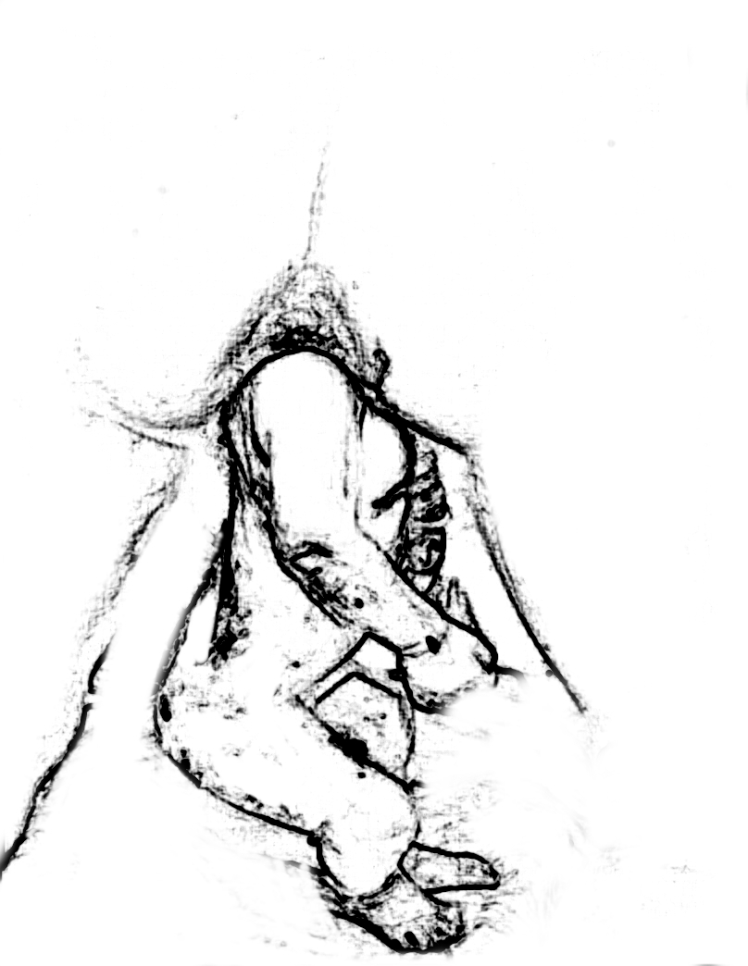
When this process has not occurred normally, usually due to the anterior arm becoming entrapped over the symphysis pubis in a nuchal position, the fetus will not completely rotate (see image). Attendants should recognise that this situation will not resolve spontaneously without intervention, and assistance should not be delayed. In order to restore the mechanism, the anterior arm must be brought down, either by sweeping down across the fetal face, or if nuchal, by rotational manoeuvres (Frye 2013). When women are upright, rotational manoeuvres to free a nuchal arm are performed using the bony prominences of the shoulder girdle rather than the pelvis, as the shoulder girdle is more accessible in these positions and minimises the risk of twisting the spine.

When the birth of the head is delayed, in addition to a modified Mariceau-Smellie-Veit, with the woman kneeling forward, birth attendants can assist the head to flex using forward pressure on the fetal chest — ‘shoulder press.’ (see picture series) This is applied in the sub-clavicular space, using either the fingers along the ridge, or the thumbs at the distal end of the clavicle, with the attendant’s fingers wrapped around the fetal shoulders. When the fetal body is brought straight back through the maternal legs and towards the maternal abdomen, the pubic bone will assist head flexion. However, if the fetal head is extended and caught at the inlet, the attendant may need to lift the fetal body to displace the head to a higher station, and rotate into the oblique or transverse diameter to assist engagement, before the flexion described above can be achieved (Hofmeyr & Impey 2006) – ‘elevation and rotation.’ In summary: if the birth does not progress smoothly, the attendant will need to restore the mechanism.

Conclusion and continuing education
This article has summarised some of the changes occurring to the way breech births are facilitated internationally, particularly in regard to maternal position and an approach which encourages attendants to respect the mechanism. Although the research base is still, at present, limited, early studies indicate that upright breech birth is at least as safe as classical lithotomy practices for neonates, and may offer significant benefits for mothers.

If you would like to learn more about upright breech birth, my blog — The Midwife, The Mother and The Breech (www.breechbirth.org.uk) — contains information about study days throughout the UK and internationally, information about breech practical skills, and critical appraisals of research.

This article was published with a picture series, available by accessing the article through MIDIRS. I am grateful to Midwife Mary Cronk, MBE, for explaining to me how she resolved the nuchal arm situation in the sketch above, which enabled me to do the same when I encountered it, and for sharing with me a photo series which enabled me to create the sketch to share with others.

*My doctoral research at City University London is entitled, ‘Upright breech birth competency and expertise’. It has been partially funded by a grant from the Iolanthe Midwifery Society.

**With thanks to midwife, Jenny Davidson, who uses the phrase ‘tum to bum’ to teach midwives and doctors to recognise the normal rotation of a breech birth, whatever the woman’s position.

References
Banks M (1998). Breech birth: woman-wise. Hamilton: Birth International.
Beech BL (2003). Breech birth: a midwifery approach. AIMS Journal 15(4):5-7.
Bisits A (2002). Upright positioning in breech births: an obstetrician’s impression. www.birthrite.com.au/eng/education/holistic_midwifery/upright/experiences/breech.htm [Accessed 16 February 2015].
Bogner G, Strobl M, Schausberger C et al (2014). Breech delivery in the all fours position: a prospective observational comparative study with classic assistance. Journal of Perinatal Medicine [Epub ahead of print] [Accessed 14 September 2014].
Borbolla Foster A, Bagust A, Bisits A et al (2014). Lessons to be learnt in managing the breech presentation at term: an 11-year single-centre retrospective study. Australian & New Zealand Journal of Obstetrics & Gynaecology 54(4):333-9.
Buckley SJ (2015). Hormonal physiology of childbearing: evidence and implications for women, babies, and maternity care. http://childbirthconnection.org/pdfs/CC.NPWF.HPoC.Report.2015.pdf [Accessed 4 June 2015].
Chandraharan E, Arulkumaran S (2012). Obstetric and intrapartum emergencies: a practical guide to management. Cambridge: Cambridge University Press.
Cronk M (1998). Midwives and breech births. Practising Midwife 1(7-8):44-5.
Cronk M (2005). Hands off that breech! AIMS Journal 17(1):1, 3-4.
Dunn PM (1991). Francois Mauriceau (1637-1709) and maternal posture for parturition. Archives of Disease in Childhood 66(1):78-9.
Dunn PM (2004). Louise Bourgeois (1563-1636): royal midwife of France. Archives of Disease in Childhood: Fetal and Neonatal Edition 89(2):F185-7.
Evans J (2005). Breech birth: what are my options? Surrey: AIMS.
Evans J (2007). First, do no harm. Practising Midwife 10(8):22-3.
Evans J (2012a). Understanding physiological breech birth. Essentially MIDIRS 3(2):17-21.
Evans J (2012b). The final piece of the breech birth jigsaw? Essentially MIDIRS 3(3):46-9.
Evans J (2014). Undiagnosed breech — part of midwifery practice. Practising Midwife 17(11):27-9.
Fahy K (2011). Do the findings of the Term Breech Trial apply to spontaneous breech birth? Women and Birth: the Journal of the Australian College of Midwives 24(1):1-2.
Frye A (2013). Holistic midwifery: a comprehensive textbook for midwives in homebirth practice. Vol 2: care of the mother and baby from the onset of labor through the first hours after birth. 2nd ed. Portland: Labrys Press.
Goffinet F, Carayol M, Foidart JM et al (2006). Is planned vaginal delivery for breech presentation at term still an option? Results of an observational prospective survey in France and Belgium. American Journal of Obstetrics and Gynecology 194(4):1002-11.
Hannah ME, Hannah WJ, Hewson SA et al (2000). Planned caesarean section versus planned vaginal birth for breech presentation at term: a randomised multicentre trial. The Lancet 356(9239):1375-83.
Hannah ME, Hannah WJ, Hewson SA (2001). The ‘Term Breech Trial’: findings of this major international study leave a question mark over midwives’ role in breech delivery. Midwifery 17(1):74.
Hofmeyr GJ, Impey LWM (2006). The management of breech presentation. London: RCOG.
National Institute for Health and Care Excellence (2014). Intrapartum care: care of healthy women and their babies during childbirth. London: NICE.
PROMPT Maternity Foundation (2012). PROMPT course manual. 2nd ed. London: RCOG.
Reitter A, Daviss BA, Bisits A et al (2014). Does pregnancy and/or shifting positions create more room in a woman’s pelvis? American Journal of Obstetrics and Gynecology 211(6):662.
Scamell M (2010). Can all-fours breech birth ever be a reality within the NHS? Practising Midwife 13(7):29-30.
Speert H (1957). Obstetric-gynecologic eponyms: François Mauriceau and his maneuver in breech delivery. Obstetrics and Gynecology 9(3):371-6.
Walker S (2013). Undiagnosed breech: towards a woman-centred approach. British Journal of Midwifery 21(5):316-18, 20-2.

Walker S. MIDIRS Midwifery Digest, vol 25, no 3, September 2015, pp ??
Original article. © MIDIRS 2015.

